** COMSATS University Islamabad, Lahore Campus**

□Sessional-1 □Sessional-II √Terminal Examination – Spring 2021

|  |  |  |  |  |  |  |  |  |  |
| --- | --- | --- | --- | --- | --- | --- | --- | --- | --- |
| Course Title: | Human Computer Interaction | | | | Course Code: | | CSC 356 | Credit Hours: | 3(2,1) |
| Course Instructor/s: | Amaid Zia ,Dr.Faizan, Miss Sara Muneeb | | | | Programme Name: | | BS Computer Science ,  BS Software Engineering | | |
| Semester: | 7th | Batch: | SP18-BCS/BSE | Section: | A,B,C,D | | Date: |  | |
| Time Allowed: | 180 Minutes | | | | Maximum Marks: | | | 50 | |
| Student Name: |  | | | | Reg. No. |  | | | |
| Important Instructions / Guidelines:   * Write answers in the space provided | | | | | | | | | |

### Question 1[10 Marks]

#### part 1 [2 marks]

What should a designer do in order to get a better idea of the user's mental model ?

|  |
| --- |
|  |

#### part 2 [8 marks]

In order to be more effective a restaurant reservation app is created . The app not only allows you to book a reservation in selected restaurants but also helps you to order food and pay for it in advance too .

The following is a concept sketch for the reservation page .

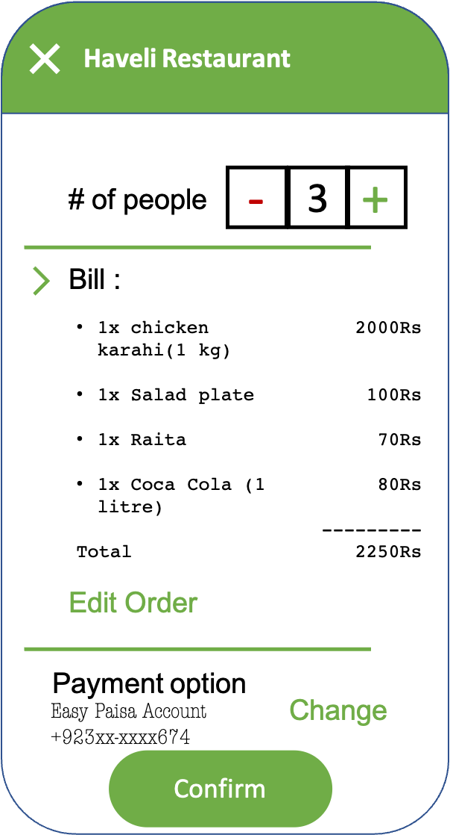

List 2 affordances , 2 constraints, 2 mappings and 2 casualties for the concept sketch above.

|  |  |
| --- | --- |
| Affordances | 1. |
| 2. |
| Constraints | 1. |
| 2. |
| Mappings | 1. |
| 2. |
| Causalities | 1. |
| 2. |

### 

### Question 2[10 Marks]

#### part 1 [2 marks]

Historically, Computer experience was not always considered an important factor while designing a product but nowadays it is considered as one of the most significant factors . Why do you think computer experience is an important consideration today even when the product has little or nothing to do with computers ?

|  |
| --- |
|  |

#### part 2 [2x3 marks]

What sort of error is being prevented in the following scenarios. Provide justification for your answers.

**Scenario 1:**

When adding a beneficiary , from an online banking application , the app specifies the format in which the beneficiary’s account number should be entered (like encircled in the figure below)

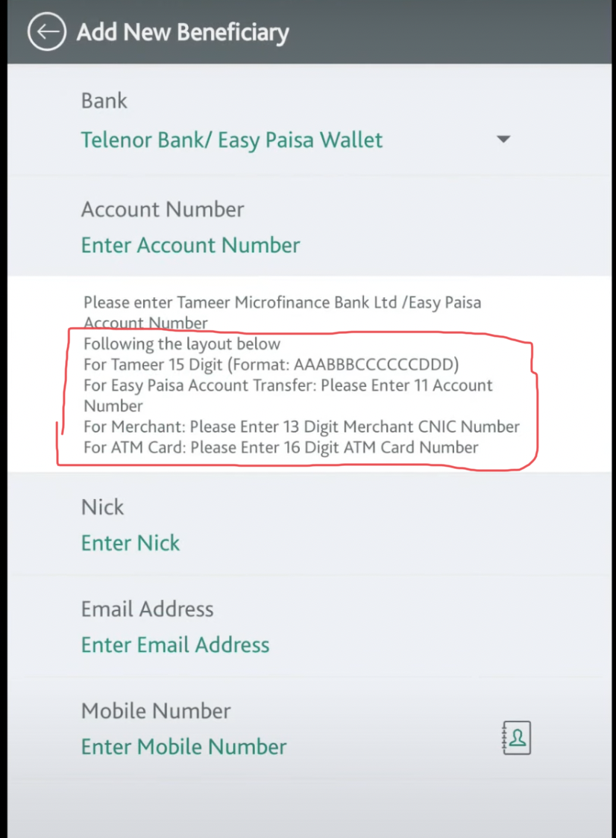

|  |  |
| --- | --- |
| **Type of error being prevented** |  |
| **Justification** |  |

**Scenario 2:**

The emergency stop button on control panel of a machine needs to be rotated for activation whereas all the other buttons surrounding it are push buttons (see figure below for reference)

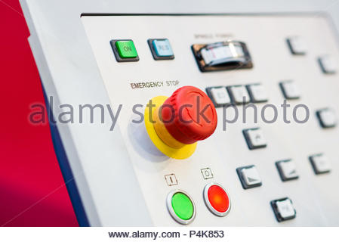

|  |  |
| --- | --- |
| **Type of error being prevented** |  |
| **Justification** |  |

#### part 3 [2 marks]

Please state what accommodations would you make in the design to avoid the errors in the following scenario.

**Scenario:**

A vacuum cleaner consists of various parts that must be assembled together. In one instance , the parts were not assembled tightly together and as a result ,when the vacuum was turned on , the assembly became undone.

|  |  |
| --- | --- |
| **Error prevention** |  |

### Question 3[10 Marks]

A company wishes to develop a machine that can cut many different types of vegetables at a very high rate. It is required that the machine should be able to cut about 5000 vegetable pieces per minute at its maximum capacity . However , this rate may be changed by varying parameters on a connected computer.

#### part 1 [4 marks]

In order to better understand the user’s goals the company wishes to conduct user research. The research would be used to develop user personas which will in turn help the design team make decisions about the product.

Please list 4 behavioral variables that you think might be helpful for the design team in order to develop personas .

|  |  |
| --- | --- |
| **#** | **Behavioral Variable** |
| 1 |  |
| 2 |  |
| 3 |  |
| 4 |  |

Suppose that the design team comes up with the following personas

1. A housewife who wants to cut the vegetables so that she can save time while cooking food for her family.
2. A small burger joint worker who wants to pre-cut the vegetables for making burgers . The joint has a small but loyal customer base.
3. A factory technician operating the machine . The factory wants package sliced vegetables so that they could be sold at various departmental stores.

#### part 2 [3 marks]

From the above persona’s list. Which one should be the primary persona. Provide justification for your answer.

|  |  |
| --- | --- |
| **Primary Persona :** | **Justification :** |

#### part 3 [3 marks]

Write a brief context scenario that describes how the machine will serve its user

|  |
| --- |
|  |

### Question 4[10 Marks]

Suppose you have two different UI designs of an e-commerce website that sales computer related accessories. You need to conduct evaluation on both the UI designs in order to compare their efficiency as well as usability.

Briefly describe how you will design your experiments with a smaller number of participants to compare user preferences and why?[3] Also indicate what kind of data you will gather to compare UI efficiency [4] as well as usability [3]?

|  |
| --- |
|  |

### Question 5[10 Marks]

Have a look at figure-1 and figure-2 below, and identify what icon design principles have been violated while designing these icons. [5+5]

**

*Figure 1*

**

*Figure 2*

|  |  |
| --- | --- |
| Figure 1 | Figure 2 |